To the Executive Officer of
United Nations Environment Programme – UNEP
executiveoffice@unep.org

Dear Executive Officer,

Charter OCEANS FOR ALL
A new battle is underway to wave the rules or to gain control over vast areas of our oceans and poles. Will the battle ever stop?
Yes it will, when there is nobody left to battle with. Yes, when Nature is completely exhausted. Yes, when most of our leaders continue to think in the way they do. Selfishly and shortsightedly.
To stop the battle soon and to see to it that everyone is satisfied and living a decent life, economics and politics and even part of religious thought have to change. From mainly money-oriented and greed-driven machines to humanity-oriented and peace-driven instruments.
Instruments that aim at the common good: the welfare of the entire planet, not just of its people, but also of Nature.
Various countries are claiming incredibly vast areas of land at the bottom of our seas and oceans, as well as the poles. Going way beyond the 200 mile continental shelf limit. Never satisfied and wanting to safeguard or increase their political and economic weight for generations to come. In their countries.
What about the countries that have a small coastline or none at all? Is it justified to claim thousands of miles of ocean land starting from just a pinprick of an uninhabited island?
Will the battle for oil and other minerals continue to cause damage our planet Earth cannot sustain? Why continue to invest heavily in oil, while it is damaging Nature so much?
Have we had to come to the 21st century to decide to start everything over again? Or to let it happen? Waging wars and battles to rule the waves or rather to have a “superior” welfare system in one country while utter misery in another.
Sorry, but that is surely not the way to go. It is time to change gears. And yes, drastically, in reverse.
Going at the speed we are going today, the probability is there will be very few future generations left.
Declaring the entire bottom of our oceans outside the 200 mile limit as well as the poles the Nature-leased property of Humanity. That is the right direction to take.
Sharing new-gained wealth from it can then be spent equitably on the development of all our countries and on Nature care to the benefit of many, many generations to come. Finally a way to battle against the disgraceful poverty in many countries and against pollution that is slowly killing our planet.
May we ask you to take a world vision? And help to promote and finetune the Oceans for all Charter (see www.oceansforall.org)? And help to convince world leaders to sign it.
Many thanks for your valued support and for the action you take to make it happen.
Kind regards,
Oceans for All

Your name

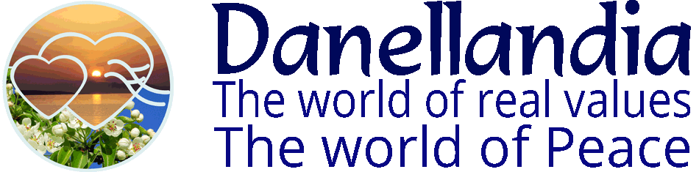

CHARTER Oceans for All
All countries should sign it.

- Oceans outside the 200 mile continental shelf limit are declared “oceans for All”
- Oceans for All and both poles are declared the property of Humanity as a whole
- Oceans for All and both poles are not to be the subject of wars and battles between nations
- Oil and other minerals found in the oceans for all and at the poles are declared the Nature-leased property of Humanity
- Exploitation of oceans for All and poles is to be regulated by the UN or a newly established organization
- Exploitation has to be carried out so as to safeguard ocean and polar life
- Exploitation has to be carried out in a sustainable way
- Proceeds of the exploitation are to be dedicated to the improvement of living conditions of all members of Humanity, irrespective of country, race, culture or religion. It includes welfare programmes, medical care, poverty reduction and education
- Proceeds of the exploitation are to be dedicated to the restoration of the damage inflicted on Nature and on the development of alternative green energy sources.

Danellandia Peace Foundation
www.danellandia.org

